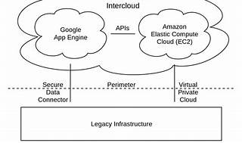

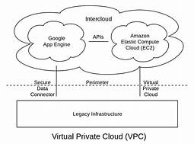

Explore

Certainly! In a nutshell, a **Virtual Private Cloud (VPC)** is a secure, isolated private cloud hosted within a public cloud. [VPC customers can run code, store data, host websites, and perform other tasks typically associated with private clouds, but the private cloud infrastructure is remotely hosted by a public cloud provider1](https://www.cloudflare.com/learning/cloud/what-is-a-virtual-private-cloud/).

Here are **five free reference links** where you can learn more about VPCs:

1. [**Amazon VPC Course by Simplilearn**](https://www.simplilearn.com/free-amazon-virtual-private-cloud-skillup): This beginner-level course covers VPC fundamentals, security, and network configurations. [It includes practical examples and provides a completion certificate](https://www.cloudflare.com/learning/cloud/what-is-a-virtual-private-cloud/)[2](https://www.simplilearn.com/free-amazon-virtual-private-cloud-skillup).
2. [**IBM’s Introduction to Amazon VPC**](https://www.ibm.com/topics/vpc): Explore how to establish your own private cloud-like environment using shared public cloud infrastructure[3](https://www.ibm.com/topics/vpc).
3. [**Check Point Software’s VPC Overview**](https://www.checkpoint.com/cyber-hub/cloud-security/what-is-vpc-virtual-private-cloud/): Learn about VPCs as private cloud environments contained within a public cloud, ensuring isolation and security[4](https://www.checkpoint.com/cyber-hub/cloud-security/what-is-vpc-virtual-private-cloud/).
4. [**W3Schools’ Amazon VPC Training**](https://www.w3schools.com/training/aws/introduction-to-amazon-virtual-private-cloud-vpc.php): Dive into features and components of typical Amazon VPC configurations[5](https://www.w3schools.com/training/aws/introduction-to-amazon-virtual-private-cloud-vpc.php).
5. [**Coursera’s Create a VPC Using AWS**](https://www.coursera.org/projects/create-virtual-private-cloud-vpc-aws): Explore VPC networks in a business context and set up an Amazon Web Services (AWS) account[6](https://www.coursera.org/projects/create-virtual-private-cloud-vpc-aws).

Feel free to explore these resources to enhance your understanding of VPCs! 🌐🔒